APPLICATION FOR  REPRODUCTION RIGHT | 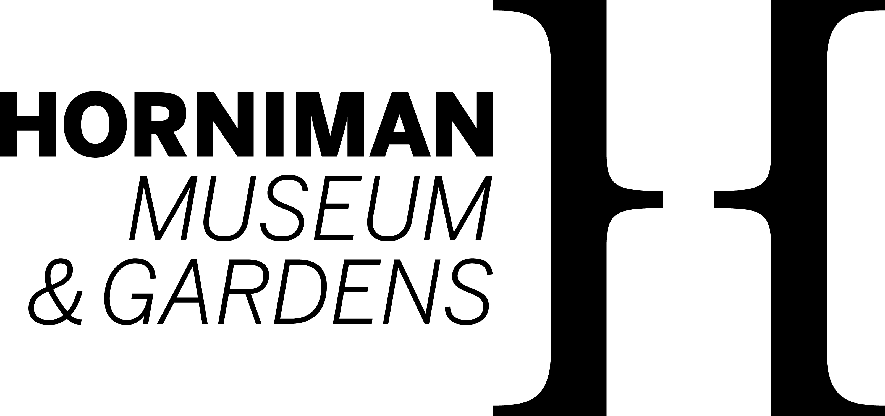
 | Horniman Museum and Gardens | Telephone
 | 100 London Road | +44 (0)20 8699 1872 | images@horniman.ac.uk
 | Forest Hill
 | London SE23 3PQ |  | horniman.ac.uk
Client details
Client: |  |  | Permission granted by:
Address: |  |  | Date:
 |  |  | Fee:
 |  |  | Invoice no:
 |  |  | Transaction no:
Contact
Telephone: |  |  | For Museum use only:

PERMISSION IS REQUESTED TO REPRODUCE THE FOLLOWING:
Brief description of subject | Image Number | Museum number | Col  B&W

PUBLICATION DETAILS:
Title of Publication:
Author/Editor:
Size (quantity) of print run:
Selling Price:
Approximate date of publication:
Countries of Distribution:
Language rights required:
Other uses (please specify):

CREDIT LINE: © HORNIMAN MUSEUM AND GARDENS.
Please also include the Museum’s object number and object name where possible.

The declaration overleaf must be completed
TERMS AND CONDITIONS OF REPRODUCTION
1. (a) Reproduction rights (if and when granted) are strictly limited to the use, period of time and territory specified and unless otherwise agreed in writing relate to a single publication in a single size with text (if any) in one language only.
(b) Reproduction rights are not granted exclusively to the Client except when specified.
(c) Reproduction rights granted are personal to the Client and may not be assigned, nor may any picture submitted to the Client be loaned or transferred to third parties save for the purpose of the exercise by the Client of such reproduction rights.
(d) Any reproduction rights granted are by way of licence and no partial or other assignment of copyright shall be implied.

2. (a) Until the reproduction fee has been invoiced neither party is committed to grant or acquire any reproduction rights in any picture. After a fee has been agreed and an invoice issued there is a firm and binding contract whereby the Horniman Museum and Gardens is committed to grant reproduction rights and the Client to acquire them. If after such invoicing but before payment the Client requests cancellation of the reproduction rights the Horniman Museum and Gardens may in discretion cancel subject to the Client paying a cancellation fee.
(b) The Client's right to reproduce a picture arises only when the Horniman Museum and Gardens invoice relating to the grant of such right is fully paid. Any reproduction before payment of the invoice constitutes an infringement of rights and a breach of this Agreement entitling the Horniman Museum and Gardens to rescind the Agreement and rendering the Client liable for the payment of damages.
(c) The Client agrees to Indemnify the Horniman Museum and Gardens in respect of any claim or damages or any loss or costs arising in any manner from the reproduction without proper reproduction rights of any picture supplied to the Client by the Horniman Museum and Gardens.

3. (a) The Horniman Museum and Gardens’ invoice shall be paid within thirty days of issue save in the case of newspaper, periodical and broadcasting clients where payment shall be no later than the end of the calendar month immediately succeeding publication or use.
(b) If the payment is not made in accordance with (a) above them the Horniman Museum and Gardens may rescind this Agreement and recover damages, or, at its option, may charge interest on the overdue amount at 2% per month on the outstanding balance.
(c) Any bank or financial fees for the transfer of payment to the Horniman must be paid by the requester of the image.

4. (a) Unless otherwise agreed in writing if any picture reproduced by the Client omits the Credit Line specified the reproduction fee payable by the Client shall be subject to a 50% increase.
(b) The right to a credit is asserted in accordance with sections 77 & 78 Copyright, Designs and Patents Act 1988.

5. No addition to, deletion from or alteration to or adaptation of a picture may be made without the written permission of the Horniman Museum and Gardens.

6. On the publishing date two COMPLETE copies of each publication must be forwarded to the Horniman Museum and Gardens for record purposes.

7. This agreement shall be subject to and construed according to English Law and the parties agree to accept the exclusive direction of the Courts of England.

DECLARATION:
This application confirms our acceptance of the terms and conditions printed above.
Name (Block Capitals): |  | Signature:
Position in Company: |  | Date:

Signed on behalf of the Horniman Public Museum and Public Park Trust.
Name (Block Capitals): |  | Signature:
Position: |  | Date:

Horniman Public Museum and Public Park Trust
Core-funded by the Department for Digital Culture Media and Sport
Company registration no. 245693. Registered office as above
Registered charity no. 80725

